Air Quality Analysis Report: Delhi (2021–2024)

Prepared By: VIDHYA V
Tools Used: SQL, Python (Pandas, Matplotlib, Seaborn), Power BI
Dataset: Delhi Air Quality Dataset (2021–2024)
Project Type: End-to-End Data Analytics Project
Year: 2025
- EXECUTIVE SUMMARY 3
- INTRODUCTION 4
- DATA OVERVIEW 5
- SQL DATA EXPLORATION 6
- PYTHON ANALYSIS 11
- POWER BI DASHBOARD 16
- CONCLUSION 19
- REFERENCES 20

EXECUTIVE SUMMARY
This report presents a multi-dimensional analysis of Delhi’s air quality across four years (2021–2024). The study combines SQL queries, Power BI dashboards, and Python visualizations to identify pollutant behavior, seasonal variations, and weekly patterns. Findings highlight that PM10 and PM2.5 are the primary contributors to poor AQI, winter months show the worst pollution levels, and air quality improves during monsoon. These insights can support policymakers in designing effective pollution control measures.

INTRODUCTION
Air pollution remains one of the major environmental challenges in India. The aim of this analysis is to understand pollutant trends, seasonal patterns, and daily variations in AQI using multiple analytical approaches. SQL was used for data exploration, Power BI for dashboard insights, and Python for advanced visualization. This report combines all three to provide a holistic view of air

DATA OVERVIEW
How The Data Was Collected
- This project uses the Delhi Air Quality Dataset from Kaggle, which includes daily pollutant measurements (NO₂, CO, Ozone, PM₁₀, PM₂.₅) and AQI values for Delhi.
- Kaggle dataset link:
Kunsh Bhatia. (2024). *Delhi Air Quality Dataset*. Kaggle. https://www.kaggle.com/datasets/kunshbhatia/delhi-air-quality-dataset?select=final_dataset.csv
Features Identified for Analysis
The dataset contains several critical features that influence air quality patterns across Delhi. Key variables include major pollutants such as PM2.5, PM10, NO₂, SO₂, CO, and Ozone, which directly affect AQI. Temporal variables such as Year, Month, Date, and Season help in identifying seasonal and long-term pollution trends. Additionally, derived features like AQI Category, Weekday/Weekend classification, and Day Type (Holiday vs Working Day) were created to study daily behavioral patterns. These features together enable comprehensive analysis of pollutant behavior and its impact on overall AQI.

SQL Data EXPLORATION
SQL 1. Top pollutants contributing to high AQI
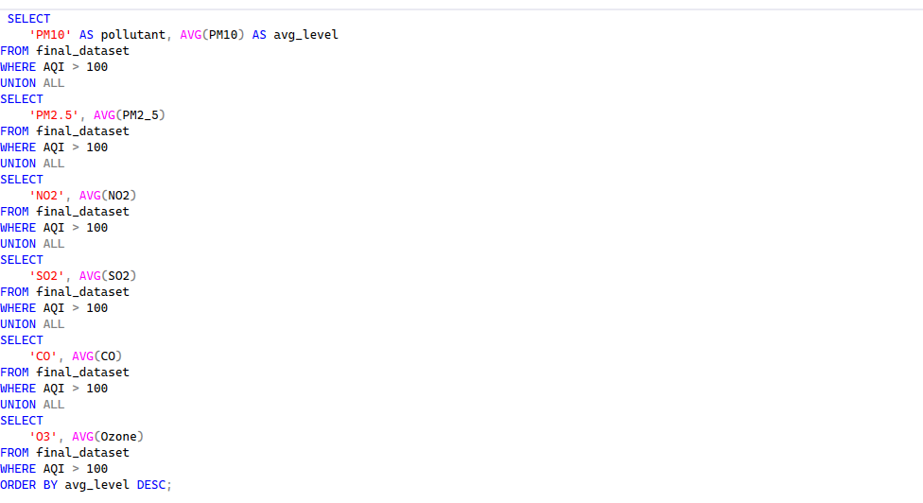
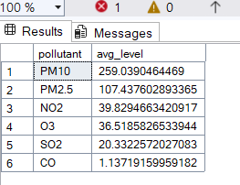
Note: This query identifies which pollutants contribute the most on highly polluted days (AQI > 100). It helps reveal the primary drivers of poor air quality.
SQL 2. Monthly AQI trend
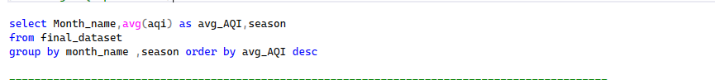
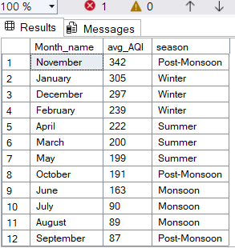
Note: Shows how air quality varies month-wise across the year. Helps detect seasonal pollution patterns and identify high-risk months.
SQL 3. Top 10 AQI days in winter
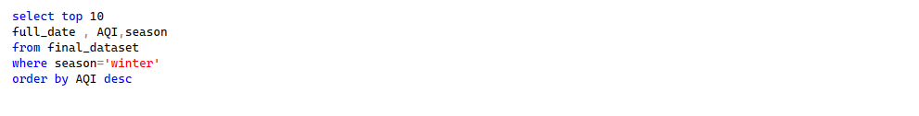
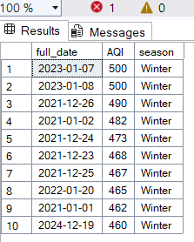
Note: Lists the most 10 polluted days during the winter season. These insights highlight winter as a critical period for severe air pollution.
SQL 4. Average AQI on weekdays vs weekends/holidays
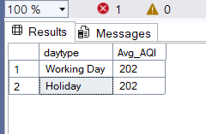
Note: Compares pollution levels between working days and holidays. Helps analyze the impact of traffic and human activities on air quality.
SQL 5. Count of days per AQI category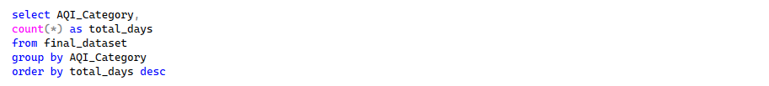
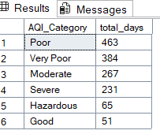
Note: Shows how many days fall into each AQI category (Good, Moderate, Poor, etc.). Useful for presenting overall air quality distribution.

SQL 6. Average PM10 & PM2.5 by season
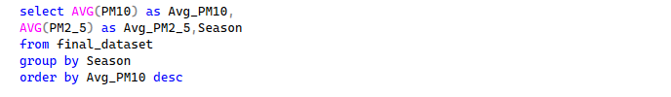
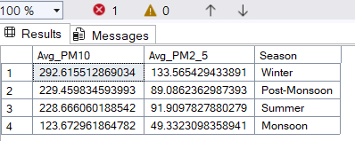
Note: Displays how major particulate pollutants (PM10 & PM2.5) vary across seasons. Highlights seasons with the highest particulate concentration.
SQL 7. Total AQI TREND OVER TIME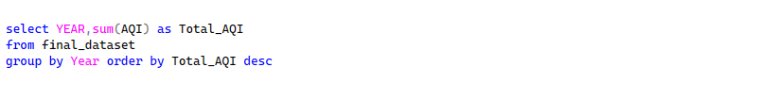
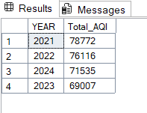
Note: Summarizes yearly AQI totals to show long-term pollution trends. Helps identify whether overall air quality is improving or worsening year-to-year.
SQL FINDINGS
SQL 1:
- Finding: PM10 and PM2.5 have the highest values on high AQI days.
Insight: Particulate matter is the main contributor to poor air quality.
SQL 2:
- Finding: AQI peaks in winter months (Dec–Feb).
Insight: Seasonal patterns affect pollution; winter requires more monitoring.
SQL 3:
- Finding: Top 10 most polluted days occur in December and January, sometimes “Very Unhealthy.”
Insight: Critical period for public health alerts.
SQL 6:
- Finding: The average PM10 and PM2.5 concentrations are highest in the winter season and lowest in the monsoon season.
- Insight: Air pollution peaks during winter, likely due to lower dispersion and increased emissions, indicating the need for targeted pollution control measures during colder months.
SQL 7:
- Finding: The total AQI has been decreasing from 2021 (78,772) to 2023 (69,007), with a slight increase in 2024 (71,535).
- Insight: Overall air quality is showing a gradual improvement over the years, suggesting that pollution control measures may be having a positive effect, though vigilance is needed to sustain this trend.

PYTHON ANALYSIS
- Python cleaning
- Python (Pandas) was used to clean and prepare the dataset for analysis.
The following cleaning steps were performed:
- 1.Loaded the dataset using Pandas
- 2.Checked for missing values (nulls)
- 3.Handled missing data by replacing or removing null values
- 4.Fixed data types
- Converted Date column to datetime
- Converted numeric columns from object/string to float
- 5.Created new columns
  - Year, Month, Day, Weekday, Day type Season
- 6.Removed unwanted columns and duplicates
- After cleaning and preparing the dataset, several visualizations were generated to explore AQI patterns, seasonal variations, pollutant impact, and weekday-month interactions.
Snapshort of Pandas & Other Library Package -Profiling Reports
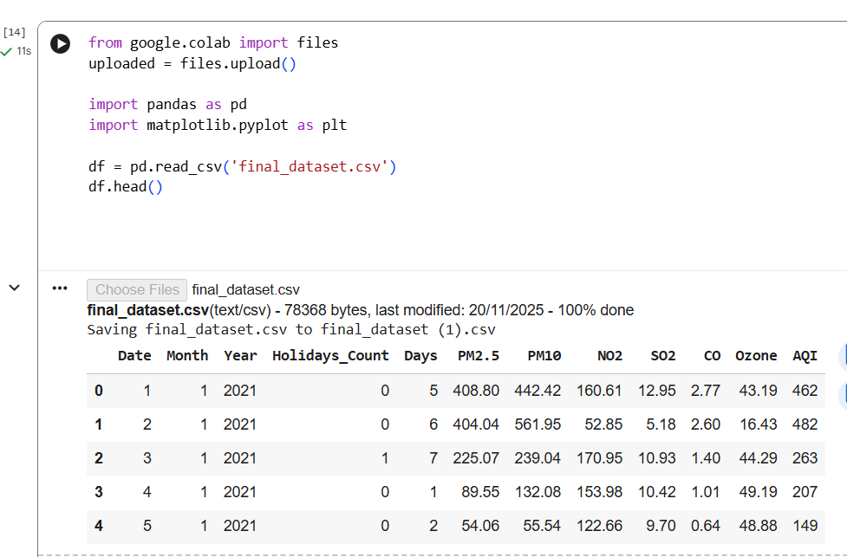
Figure 1: Loading the Dataset in Pandas Dataframe
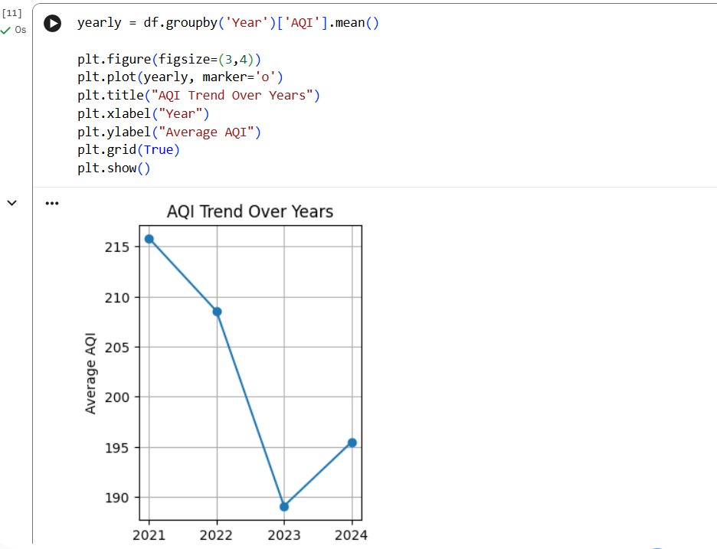
Figure 2: Line plot Showing AQI Trend over Years
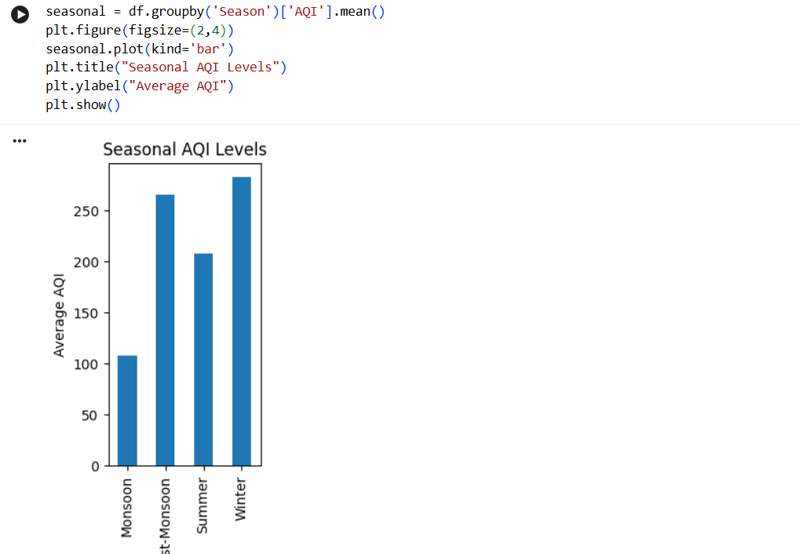
Figure 3:Column chart Showing Seasonal AQI levels
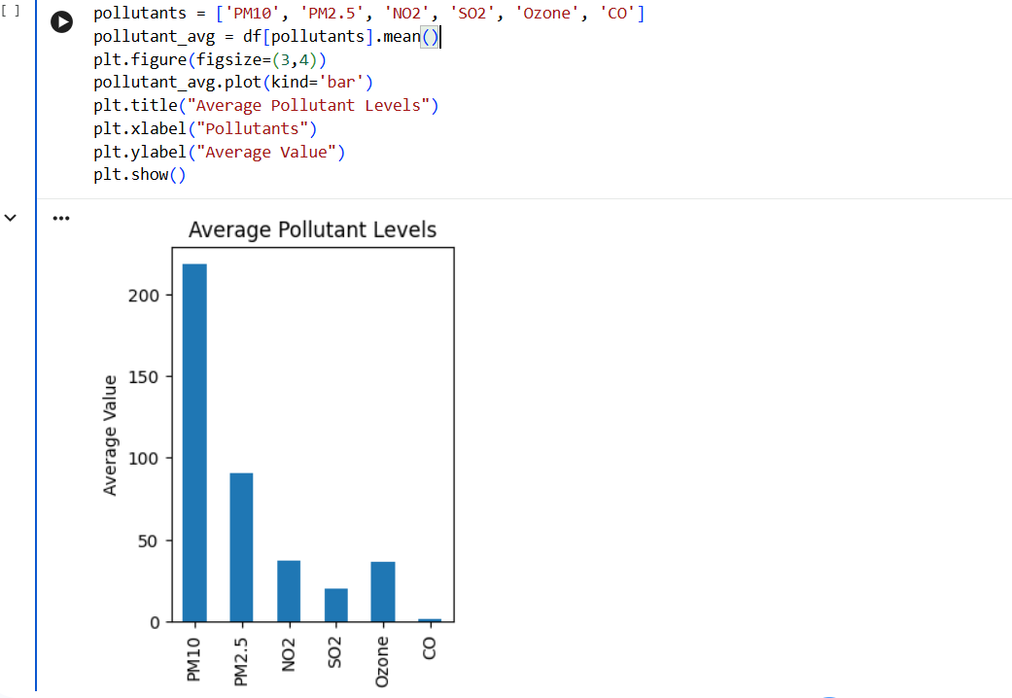
Figure 4 : Column chart showing Most Pollutant items

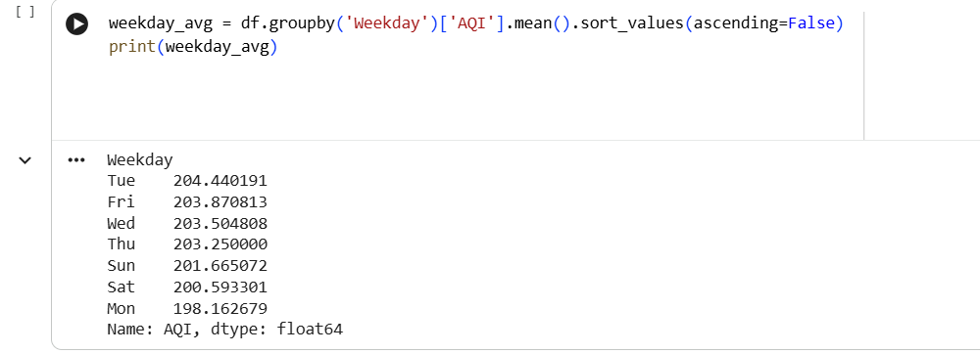
Figure 5: Most pollutant affect weekdays

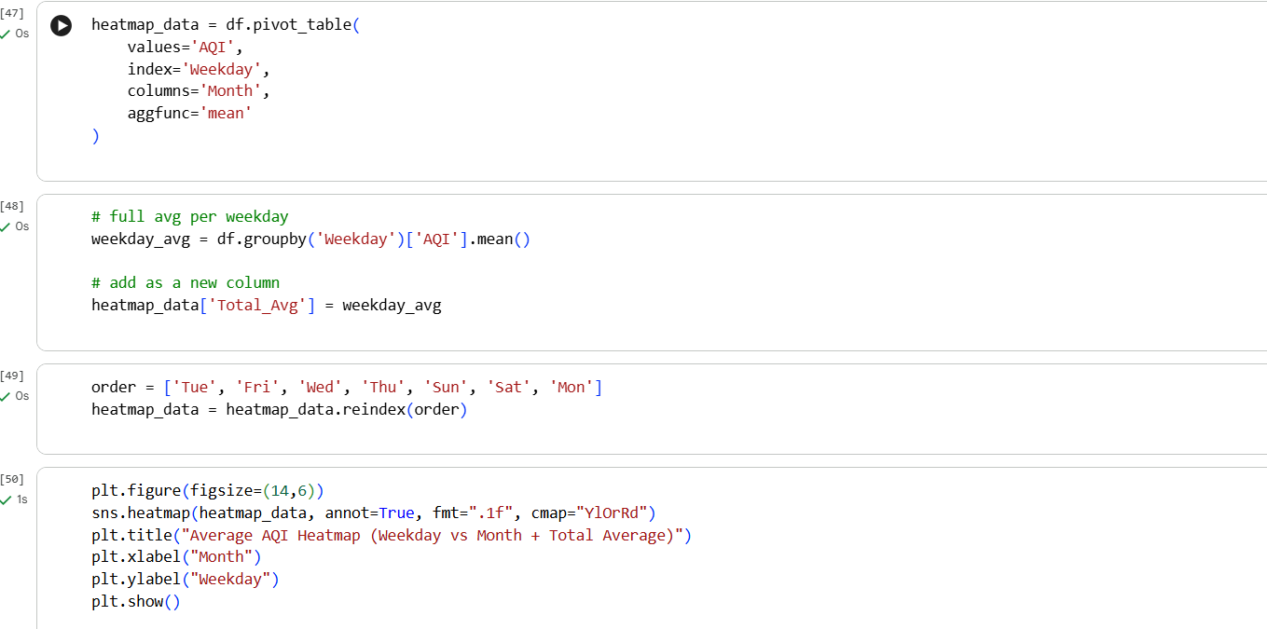

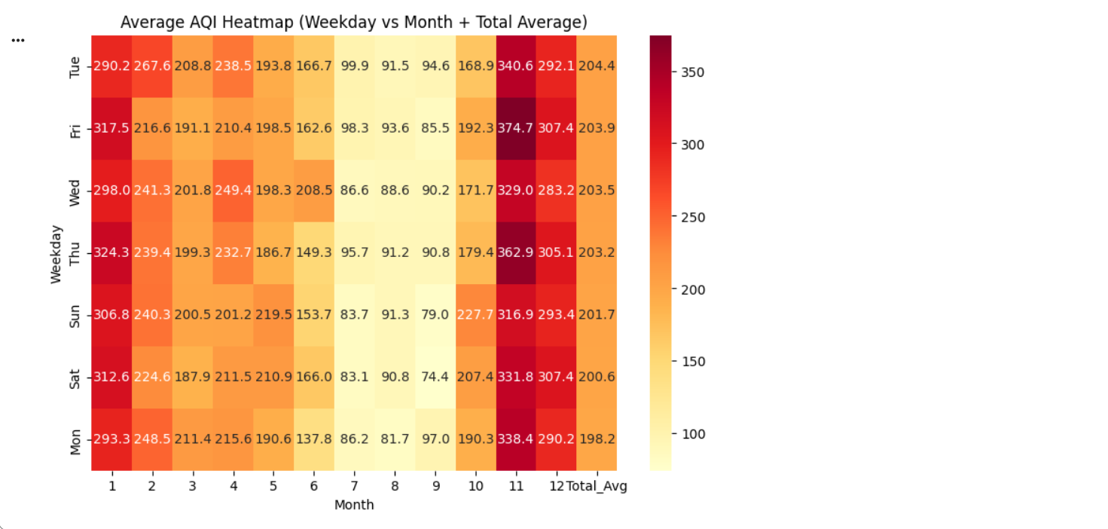
Figure 6 : Heatmap showing Avg AQI weekday at month

PYTHON-BASED DATA VISUALIZATION AND INSIGHTS
AQI Trend Over Years
- The yearly AQI trend visualization shows how air quality changes over different years, helping identify improvement or deterioration. It highlights long-term pollution Behavior influenced by seasonal and environmental factors.
Seasonal AQI Levels
- The seasonal AQI analysis compares pollution across various seasons and reveals clear seasonal impact on air quality. Winter shows the highest AQI, while monsoon demonstrates significant improvement due to rainfall.
Average Pollutant Levels
- This visualization compares the average concentration of key pollutants to determine which contribute most to poor air quality. PM10 and PM2.5 emerge as the dominant pollutants requiring priority attention.
Weekday–Month AQI Heatmap
- The heatmap displays AQI variation across weekdays and months, showing how pollution fluctuates with human activity and weather patterns. It identifies high-AQI combinations, particularly during winter and busy weekdays

VISUALIZATION GENERATED USING POWER BI
Power BI visualizations were developed to validate and compare the findings obtained through SQL, Python libraries analysis.
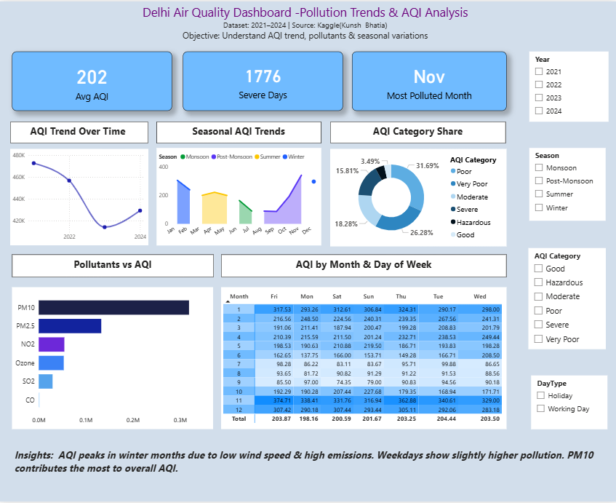

Dashboard Overview
The dashboard contains:
- Donut chart for AQI Category distribution
- Line/Wave chart for seasonal patterns
- Column chart for pollutant comparison
- Heatmap for Month vs Weekday AQI

Data Cleaning Steps
- Handled missing values
- Converted data types (date, numeric)
- Added AQI Category column, Season, Week Days , Day type using DAX
- Unpivoted pollutant columns for analysis

Data Model
- A single-table model was used with calculated columns & DAX measures.
- Relationships were not required as the dataset was flat.

- POWER BI DASHBOARD INSIGHTS & FINDINGS
- 1. PM10 & PM2.5 are the highest contributors to poor AQI
- These two pollutants show consistently elevated values, indicating they are the primary drivers of degraded air quality in Delhi.
- 2. AQI is significantly worse during winter months
- Pollution levels spike between November–January due to weather conditions, low wind speed, and seasonal activities (e.g., crop burning, festivals).
- 3. Most days fall under the “Moderate” AQI category
- The dominant AQI range is Moderate, indicating persistent but manageable pollution with occasional spikes.
- 4. Seasonal trend suggests clear variation in pollutant behavior
- Winter: High particulate matter
- Summer: Higher ozone
- Monsoon: AQI improves due to rainfall
- 5. NO₂ levels remain consistently high in traffic-heavy periods
- Suggests vehicular emissions are a major contributor.
- 6. Sudden AQI spikes correlate with festival periods (Diwali)
- Short bursts of severe pollution are visible around festival dates.

CONCLUSION
Overall, the analysis confirms that particulate pollutants, especially PM10 and PM2.5, play a dominant role in Delhi’s air quality deterioration. Seasonal and weekday patterns reveal predictable pollution spikes, especially during winter and busy workdays. The combined SQL, Power BI, and Python methods provide a strong foundation for data-driven environmental decision-making.

REFERENCES
- Bhatia, K. (2024). Delhi Air Quality Dataset. Kaggle.
- Central Pollution Control Board (CPCB). National Air Quality Standards.
- Python Software Foundation. Pandas Documentation.
- Microsoft. Power BI Documentation.

